Título

Nombre y Apellidos del Estudiante

Universidad Internacional de la Rioja, Logroño (España)

Fecha

Palabras Clave

Tres a cinco palabras clave ordenadas alfabéticamente y separadas por comas.

Resumen

Breve resumen del trabajo realizado (extensión máxima: 150 palabras). Este resumen debe incluir el objetivo o propósito de la investigación, la metodología, los resultados y las conclusiones.

I. Introducción

I

intoducción en la que debes resumir de forma esquemática pero suficientemente clara lo esencial de cada una de las partes del trabajo.

La lectura de esta introducción ha de dar una primera idea clara del desarrollo, las conclusiones a las que se ha llegado y del procedimiento seguido.

II. DESARROLLO

Desarrollar la descripción de tu contribución.

XXXXXXXXXXXXXXXXXXXXXXXXXXXXXXXXXXXXXXXXXXXXXXXXXXXXXXXXXXXXXXXXXX.

XXXXXXXXXXXXXXXXXXXXXXXXXXXXXXXXXXXXXXXXXXXXXXXXXXXXXXXXXXXXXXXXXXXXXXXXXXXXXXXXXXXXXXXXXXXXXXXXXXXXXXXX.

XXXXXXXXXXXXXXXXXXXXXXXXXXXXXXXXXXXXXXXXXXXXXXXXXXXXXXXXXXXXXXXXXXXXX.

(Young, 1964) (Chen, 1993)

XXXXXXXXXXXXXXXXXXXXXXXXXXXXXXXXXXXXXXXXXXXXXXXXXXXXXXXXXXXXXXXXXXXX.

En la Tabla I …

XXXXXXXXXXXXXXXXXXXXXXXXXXXXXXXXXXXXXXXXXXXXXXXXXXXXXXXXXXXXXXXXXXXXXXXXXXXXXXXXXXXXXXXXXXXXXXXXXXXXXXX.

Tabla I

Units for Magnetic Properties

|  |  |  |
| --- | --- | --- |
| Symbol | Quantity | Conversion from Gaussian and CGS EMU to SI a |
| Φ | magnetic flux | 1 Mx → 10−8 Wb = 10−8 V·s |
| B | magnetic flux density,  magnetic induction | 1 G → 10−4 T = 10−4 Wb/m2 |
| H | magnetic field strength | 1 Oe → 103/(4π) A/m |
| μr | relative permeability | μ → μr |
| w, W | energy density | 1 erg/cm3 → 10−1 J/m3 |
| N, D | demagnetizing factor | 1 → 1/(4π) |

Vertical lines are optional in tables. Statements that serve as captions for the entire table do not need footnote letters.

aGaussian units are the same as cgs emu for magnetostatics; Mx = maxwell, G = gauss, Oe = oersted; Wb = weber, V = volt, s = second, T = tesla, m = meter, A = ampere, J = joule, kg = kilogram, H = henry.

En la Figura 1…

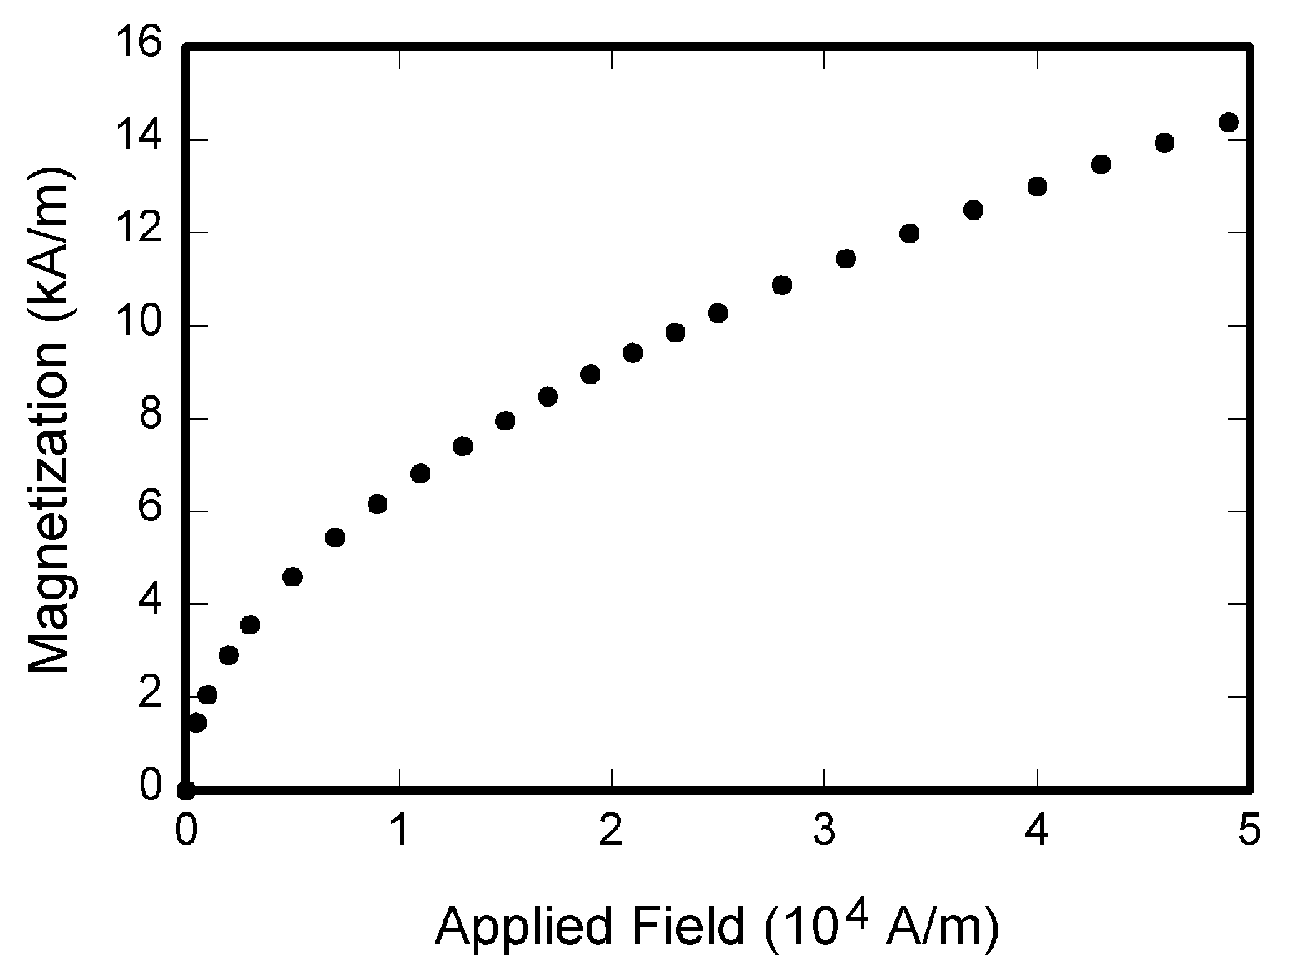

Fig. 1. Magnetization as a function of applied field. Note that “Fig.” is abbreviated. There is a period after the figure number, followed by two spaces. It is good practice to explain the significance of the figure in the caption.

iii. CONCLUSIONES

Descripción de los resultados obtenidos durante el desarrollo.

XXXXXXXXXXXXXXXXXXXXXXXXXXXXXXXXXXXXXXXXXXXXXXXXXXXXXXXXXXXXXXXXXX.

Referencias

Chen, W.-K. (1993). *Linear Networks and Systems (Book style).* Belmont, CA: Wadsworth: Mc GrawHill.

Doran, G. T. (1981). There's a S.M.A.R.T. way to write management's goals and objectives. *Management Review (AMA FORUM), 70*, 35-36.

Young, G. O. (1964). *Synthetic structure of industrial plastics (Book style with paper title and editor)* (Vols. 3 pag 15–64.). New York: Ed. McGraw-Hill.